*Learning Target:

*Critical Content:

Parallelogram | A ______________________________ with ___________ pairs of _______________________ sides __________________________.  To name a parallelogram, use the symbol ________________.
Properties of Parallelograms
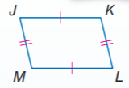  1) | If a quadrilateral is a ___________________________, then its ________________________ sides are ___________________________.
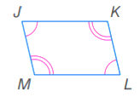  2) | If a quadrilateral is a ___________________________, then its opposites _______________ are ___________________________.
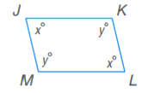  3) | If a quadrilateral is a ___________________________, then its __________________________ ________________ are ______________________________.
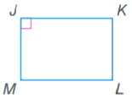  4) | If a ______________________________ has one _______________ angle, then it has _____________ _______________ angles.

Examples | 1) In $▭ABCD$, suppose $m∠A=55, AB=2.5 ft, BC=1 ft.$ Find each measure.  a) $DC$ b) $m∠B$ c) $m∠C$

Diagonals of Parallelograms
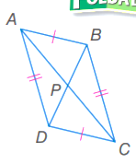  1) | If a quadrilateral is a _____________________________, then its ___________________________ _________________________ each other.
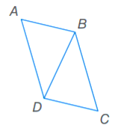  2) | If a quadrilateral is a _____________________________, then each ______________________ separates the ________________________________ into _______ congruent ______________________.

Examples  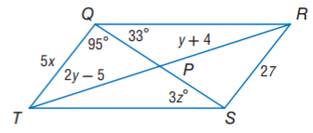 | 2) If QRST is a parallelogram, find the value of the indicated variable.  a) x b) y c) z
3) Determine the coordinates of the intersection of the diagonals of $▭FGHJ$ with vertices F(-2, 4), G(3, 5), H(2, -3), and J(-3, -4).

3) Determine the coordinates of the intersection of the diagonals of RSTU with vertices R(-8, -2), S(-6, 7), T(6, 7), and U(4, -2).

