*Learning Target:

*Critical Content:

System of inequalities-
*The solution to a system of inequalities is
*REMEMBER:

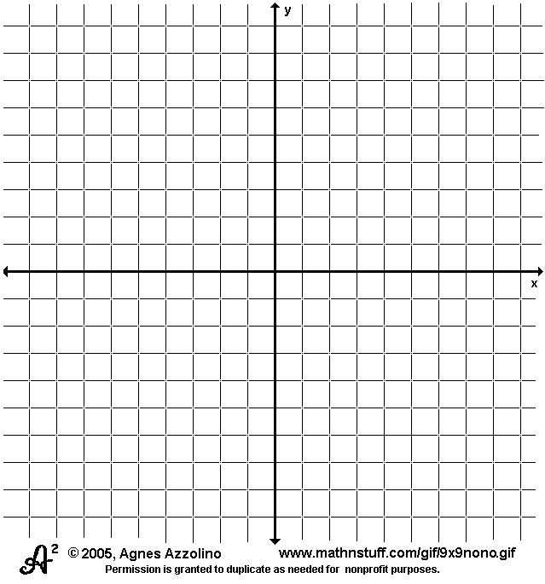
Ex1: $\left\{\begin{aligned}y>-2x+1 \\ y≤x+3\end{aligned}\right.$ Ex2: $\left\{\begin{aligned}3x-y≥2 \\ 3x-y<-5\end{aligned}\right.$

*Ex3: The Theater Club is selling shirts. They have only enough supplies to print 120 shirts. They will sell sweatshirts for $22 and t-shirts for $15, with a goal of at least $2,000 in sales. Define a system of inequalities, graph the system, and name one possible solution. Is (45, 30) a solution? Explain.

