1. A roadside vegetable stand sells pumpkins for $5 each and squashes for $3 each. One day they sold 6 more squash than pumpkins, and their sales totaled $98. Write and solve a system of equations to find how many pumpkins and squash they sold.

2. Anya makes 14 baskets during her game. Some of these baskets were worth 2 points and others were worth 3 points. In total, she scored 30 points. Write and solve a system of equations to find how many 2-point baskets she made.

3. Veronica has been saving dimes and quarters. She has 94 coins in all, and the total value is $19.30. How many dimes and how many quarters does she have?

4. The Willis Tower in Chicago is the tallest building in North America. The total height of the tower t and the antenna that stands of top of it a is 1729 feet. The difference in heights between the building and the antenna is 1171 feet. How tall is the Willis Tower?

5. Roger and Trevor went shopping for produce on the same day. They each bought some apples and some potatoes. The amount they bought and the total they paid are listed in the table below. What was the price per pound of the apples and the potatoes?
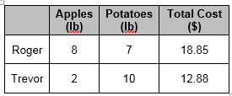

6. A library contains 2000 books. There are 3 times as many non-fiction books as fiction books. Write and solve a system of equations to determine the number of nonfiction and fiction books.

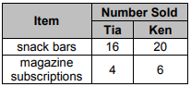
7. Tia and Ken each sold snack bars and magazine subscriptions for a school fund-raiser, as shown in the table. Tia earned $132 and Ken earned $190.
a) Define a variable and write a system of linear equations from this situation.

b) What was the price per snack bar?

6.6 Problems
8. Renee’s Pet Store never has more than a cobined total of 20 cats and dogs and never more than 8 cats. This is represented by the inequalities $x≤8$ and $x+y≤20$. Solve the system of inequailities by graphing.
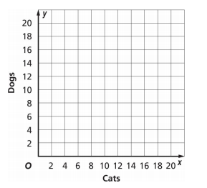

9. The minimum wage for one group of working in Texas is $7.25 per hour effective Sept 1, 2008. The graph below shows the possible weekly earnings for a person who makes at least minimum wage and works at most 40 hours. Write the system of inequalities for the graph.
