Learning Target:

Critical Content:

System of equations –
*THE SOLUTION TO A SYSTEM OF EQUATIONS IS THE ______________ WHERE THE ________ ____________

Possible Solutions:
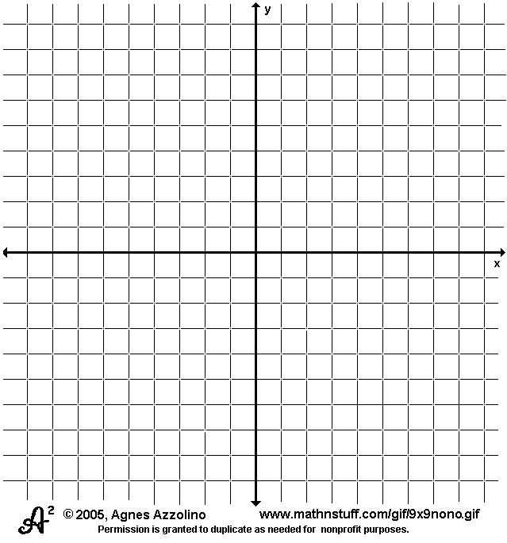
1) One Solution – lines intersect at _________ point
- the graph is ______________________ -
-the graph is _______________________ -

2) Infinite Solutions – lines are the __________ ______________
-the graph is _______________________ -
-the graph is _______________________ -

3) No Solution – lines _______________ intersect -
-the graph is _______________________ -

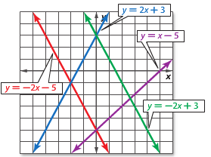
Ex1) Use the graph to determine whether each system is consistent or inconsistent and if it is independent or dependent.
a) $\left\{\begin{aligned}y=-2x+3 \\ y=x-5\end{aligned}\right.$ b) $\left\{\begin{aligned}y=-2x-5 \\ y=-2x+3\end{aligned}\right.$

*We can also solve systems of equations by _______________________.
*REMEMBER:
Ex2) Graph each system and determine the number of solutions that it has. If it has one solution, name it.
a) $\left\{\begin{aligned}y=-3x+10 \\ y=x-2\end{aligned}\right.$ b) $\left\{\begin{aligned}2x-y=-1 \\ 4x-2y=6\end{aligned}\right.$

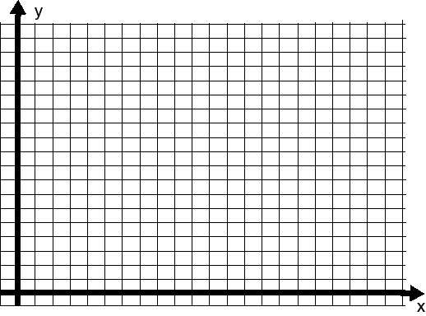
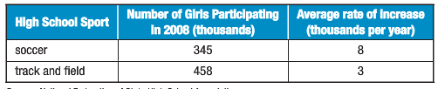
Ex3) The number of girls participating in high school soccer and track has steadily increased over the past few years. Use the information in the table to predict the approximate year when the number of girls participating in these two sports will be the same.

Ex3) Joe and Josh each want to buy a video game. Joe has $14 and saves $10 a week. Josh has $26 and saves $7 a week. In how many weeks will they have the same amount?

