*Learning Target:

*Critical Content:

Follow the following steps to solve these problems:
1) Solve the inequality for y, putting it in our favorite form y = mx + b. The equals sign will be an inequality, though.
2) Graph as you normally would following these rules:
a) If $<$ or $>$, use a dotted line.
b) If $≤$ or $≥,$use a solid line.
c) If $<$ or $≤$, shade below the line.
d) If $>$ or $≥$, shade above the line.
 | Ex1) Graph $3x-y<2$ | Ex1a) Graph $y>\frac{1}{2}x+3$ | Ex2) Graph $x+5y≤10$
Step 1) Put in y = mx + b form, but with an inequality symbol. | m = _______ b = ________ | m = ________ b = ________ | m = _______ b = ________
Step 2) Dashed or solid line?
Step 3) Shade above or below?
Step 4) Graph | 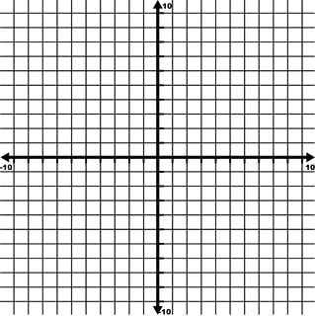

Ex3) Use a graph to solve $3x+5<14$
*DON’T DO WHAT THE BOOK SAYS HERE. Just solve like you normally would!

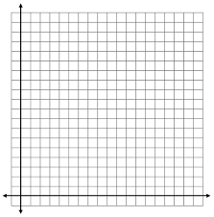
Ex4) A yearbook company promises to give the junior class a picnic if they spend at least $28,000 on yearbooks and class rings. Each yearbook costs $35, and each class ring costs $140. How many yearbooks and class rings must the junior class buy to get their picnic?

