*Learning Target:

*Critical Content:

Bivariate Data
Scatter Plot

3 Types of Correlation *FILL IN THE GRAPHS BELOW
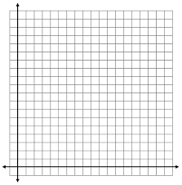
1) Positive Correlation 2) Negative Correlation 3) No Correlation

Ex1: Determine whether the graph shows a positive, negative, or no correlation. If there is a positive or negative correlation, describe the meaning in the situation.
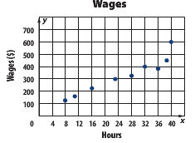
Scatter plots can show whether there is a ___________ in a set of data. When the data points all lie ___________ to a
___________, a ____________ ____ ______ or a ___________ ___________ can model the trend.
To Make a Line of Fit
Step 1:
Step 2:
Step 3:
Step 4:

Ex2: The table shows vertical drops of 9 roller coasters in the US and the number of years after 1988 that they were opened. Identify the independent and dependent variables. Is there a relationship? If so, predict the drop in a roller coaster built 25 years after 1988.
Step 1) Make a scatter plot Step 3)Write an equation in y = mx + b form. Pick two points on the line.
Step 2) Draw a line of fit
-Hit as many points as possible
-Try to have an even number of points
above and below line

Step 4) Plug 25 years after 1988 into the equation found in step 3.

Linear Interpolation

*Ex: Using the information in the previous example, find the vertical drop of a roller coaster built in 1997.

