*Learning Target:

*Critical Content:

Parallel lines –
PARALLEL LINES HAVE THE _______________________________________.
Examples | 1) Write an equation in slope-intercept form for the line that passes through (-3, 5) and is parallel to the graph of $y=2x-4$. | 1) Through (4, -1) and parallel to $y=\frac{1}{4}x+7$
Step 1: Find m
Step 2: Write in point-slope form
Step 3: Convert to slope-intercept form

Perpendicular lines –
PERPENDICULAR LINES HAVE SLOPES THAT ARE __________________________________.
Examples | 2) Is angle DFE a right angle in the logo?
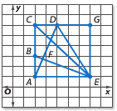 | Slope of $\overline{BE}$ =  Slope of $\overline{AD}$ =  Right angle? Explain. _________________________________________
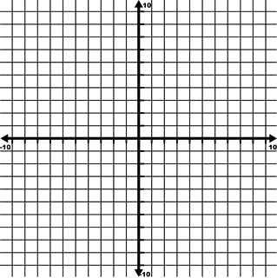 | 3) Determine whether the graphs of $y=5, x=3, and y=-2x+1$ are parallel or perpendicular. Explain.  Slope of $y=5$: ________  Slope of $x=3$: ________  Slope of $y=-2x+1$: ________  Which lines are perpendicular? ________________  Which lines are parallel? ______________________

Examples | 4) Ex4: Write an equation in slope-intercept form for the line that passes through (-4, 6) and is perpendicular to the graph of  $2x+2y=12$. | Ex4: Write an equation in slope-intercept form for the line that passes through (4, 7) and is perpendicular to the graph of $y=\frac{2}{3}x-1$
Step 1: Find m  *Make sure it is in slope-intercept form first! | Write $2x+2y=12$ in slope-intercept form:  Slope of $2x+2y=12$ is __________
Step 2: Find m of a perpendicular line. | Slope perpendicular to $2x+2y=12$ is _________
Step 3: Put it in point-slope form.
Step 4: Convert to slope-intercept form.

