*Learning Target:
*Critical Content:
Point – Slope Form:
Ex1: Write an equation in point-slope form for the Ex1: Line through (-2, 1) with a slope of -6. Graph.
line that passes through (3, -2) with a slope of 1/4 .
Then graph the equation.

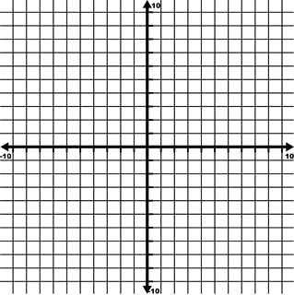

*What are the three forms of linear equations?
1.
2.
3.
Ex2: Write $y-1=-\frac{2}{3}(x-5)$ in standard form. Ex3: Write $y+3=\frac{3}{2}(x+1)$ in slope-intercept form.

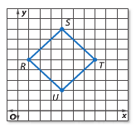
Ex4: The figure shows square RSTU.
a) Write an equation in point-slope form for the line containing side $\overline{TU}$.

b) Write an equation in standard form for the same line.

