*Learning Target:
*Critical Content:
Slope-intercept form –
Where m = ________________ and b = ___________________________.
Write an equation in slope-intercept form for the described equations. Then graph the equations.
Ex1: A slope of ¾ and a y-intercept of -2 Ex1a: A slope of -1/2 and a y-intercept of 3
y = _______x ___ ______ y = _________x ___ _______
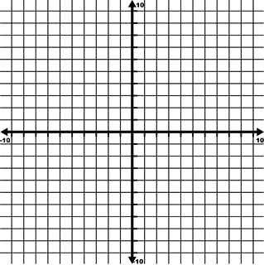

For the following examples, you need to SOLVE FOR Y FIRST! Put it in slope-intercept form.
Ex2: Graph $3x+2y=6$ Ex2a: Graph $3x-4y=12$

*If equation is y = c, it is a ___________________________________ and has a slope of ___________________.
*If equation is x = c, it is a ___________________________________ and has a slope that is _____________________.
Ex3: Graph $y=-3$ Ex3a: Graph $y=5$

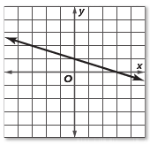
Ex4: Write an equation in slope-intercept form for the graph shown.

m = ________
b = _________
y = ________x + _________

Ex5: In 1997 about 2.6 million girls competed in high school sports. This has increased by an average of 0.06 million per year since 1997.
a) Write a linear equation to find the number of girls in sports after 1997.
m = _______
b = _______
y = ________x + _________
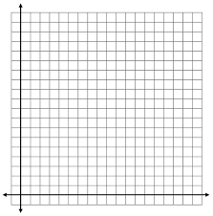
b) Graph

