*Learning Target:
*Critical Content:
*A relationship is proportional if its equation is of the form ___________, ______ and the graph passes through ______.
*These patterns can be described using a _________, a ________, and an ____________.
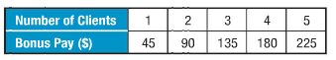
Ex: Marcos is a personal trainer. In addition to his salary, he receives a bonus for each client he sees.
a) Graph the data. Is it proportional?
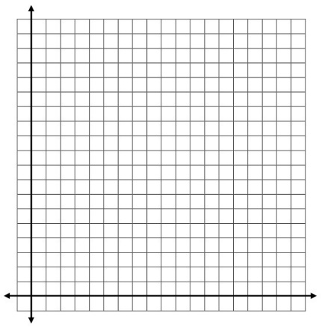

Is it linear? __________
Does it pass through the origin? _________
Is it proportional? ____________

b) Write an equation. c) Predict the amount of Marcos’s bonus if he sees 8 clients.
m = ______
b = ______
y = _______ x + ______

*Some linear equations can represent a _______________________ ___________________. This happens when the
graph is _____________, but does not go through the _____________.
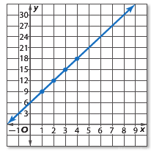
Ex: a) Write an equation in function notation for the graph.
*THIS IS JUST Y=MX+B! LOOK AT THE GRAPH.
m = ______
b = ______
y = _______ x + ______

b) Is this function proportional? Explain.

