*Learning Target:
*Critical Content:
Sequence –
Terms of the sequence –
Arithmetic sequence –
Common difference –
Ex: Determine whether each sequence is an arithmetic sequence. Explain.
a) $-4, -2, 0, 2, …$ b) $\frac{1}{2},\frac{5}{8},\frac{3}{4},\frac{13}{16},…$ 1a) -26, -22, -18, -14, …

Ex: Find the next three terms of the arithmetic sequence 15, 9, 3, -3, …

The nth term of an arithmetic sequence:
$a_{n}=$ _____ + (____ - ____)____

Ex: a) Write an equation for the nth term of the arithmetic sequence -12, -8, -4, 0, …

b) Find the 9th term of the sequence.

n | $a_{n}$
1
2
3
4
5
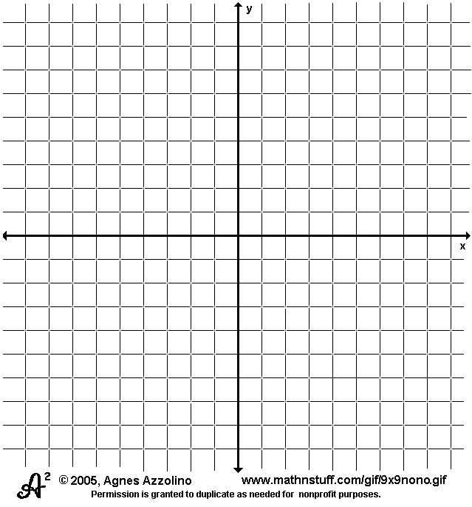
c) Graph the first five terms of the sequence.

d) Which term of the sequence is 32?
*An arithmetic sequence is a _____________ ______________ in which n is the independent variable (___) and $a_{n}$ is
the dependent variable ( ___ ) and d is the ________.

Ex: Marisol is mailing invitations to her quinceanera. The arithmetic sequence $0.42, $0.84, $1.26, $1.68, … represents the cost of postage.
a) Write a function to represent this sequence.

b) Graph the function and determine the domain.
n | f(n)
1
2
3
4
5

