*Learning Target:
*Critical Content:
Direct variation –
Constant of variation/constant of proportionality –
*y=kx always passes through the ___________. This means the x and y intercepts are _______and k is the ___________.
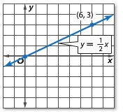
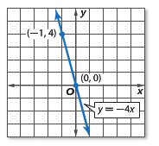
Ex: Name the constant of variation for the following equations. Also, find the slope.
a) b)
k = ______
m = _____
k = ______
m = _____

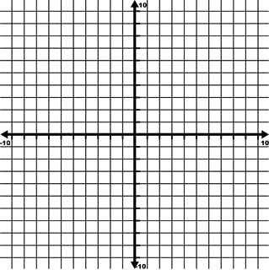
Ex: Graph $y=-6x$
m = _______
b = _______

Ex: Write and solve a direct variation equation. Suppose y varies directly as x and y = 72 when x = 8.
a) Write a direct variation equation for y and x. b) Use the direct variation equation to find x when y = 63.

One of the most common applications of direct variation is the formula ___________. _________ d varies _______ as the ______ t, and the ______ r is the __________ of _____________.
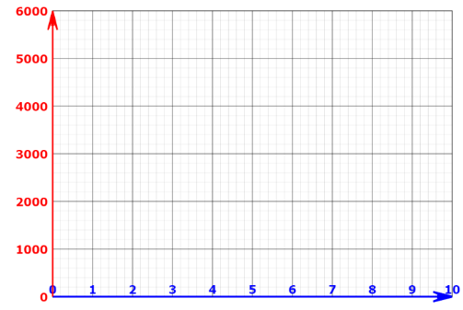
Ex: The distance a jet travels varies directly as the number of hours it flies. A jet traveled 3420 miles in 6 hours.
a) Write a direct variation equation. b) Graph the equation

c) Estimate how many hours it will take for an airliner to fly 6500 miles.

