*Learning Target:
*Critical Content:
Linear function –
Parent function –
Family of graphs –
Root –
Zeros –
*

Solve the following.
1) $0=\frac{1}{3}x-2$ 2) $3x+1=-2$ *Solve graphically
*Solve algebraically Step one: Set equal to zero.
Step two: Replace 0 with y
Step three: Graph, it’s in y=mx+b form.
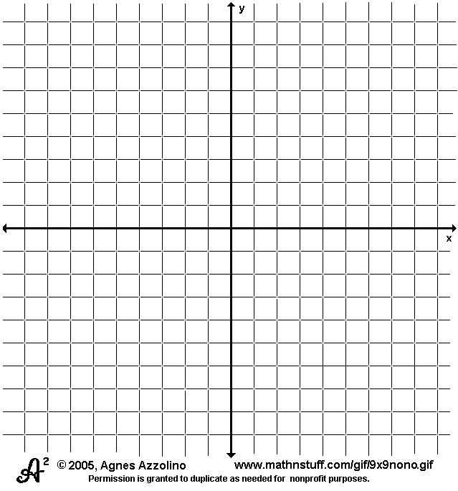
m = ___________
b = ___________
Step four: The solution is the x-intercept.
Solution: x = __________

3) Solve $3x+7=3x+1$ 4) Emily is going to the carnival. The function $m=20-0.75r$
represents the amount of money m she has left after r rides.
Find the zero of this function. What does it mean?
*Solve algebraically.

*Be careful. When solving graphically, it may provide only an _______________. Solve algebraically to find the ____________ solution.

