*Learning Target:
*Critical Content:
Linear equation –
Standard form –
Constant –
*Not a linear equation if:
Determine if the following are linear equations. Write the equation in standard form.
1a) $y=4-3x$ 1b) $6x-xy=4$ 1c) $\frac{1}{3}y=-1$

Linear equations can be represented on a coordinate graph:
x-intercept –
y-intercept –
*The graph of a linear equation has at most _____ x-intercept and _______ y-intercept.
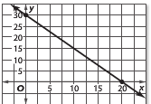
Ex2) Find the x and y intercepts of the graph on the right.

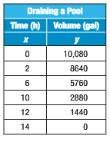
Ex3) A swimming pool is being drained at a rate of 720 gallons per hour. The table shows the function relating the volume of water in a pool and the time in hours that the pool has been draining.
a) Find the x and y intercepts.

b) Describe what the intercepts mean in the situation.

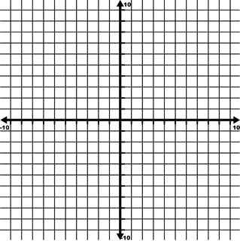
*The intercepts give us two points, we can then graph the line because 2 points make a line.
Ex4) Graph $2x+4y=16$ using the x and y intercepts.
2)Find y-intercept $→x=$ ____
1)Find x-intercept $→y=$ ____

*We can also graph using the slope and the y-intercept! YOU KNOW HOW TO DO THIS!
Ex5) Graph $y=\frac{1}{3}x+2$
*To graph in $y=mx+b$ form:
1)

2)

SLOPE: m = ___
Y-INTERCEPT: b = ____

Ex) Graph $2x-y=2$
*First, solve for y.
m = ___
b = ___

Ex) Graph $y=3$ Ex) Graph $x=7$
HORIZONTAL EQUATIONS:

VERTICAL EQUATIONS:
Ex) Graph $y=-2$ Ex) Graph $x=-9$

