*Learning Target:
*Critical Content:
Function –
*

Ex1: Determine whether each relation is a function. Explain.
a) b) 1)

*
Discrete Function –
Continuous Function –
Ex2: At an ice sculpting competition, each sculpture’s height was measured to make sure that it was within the regulated height range of 0 to 6 feet. The measurements were as follows: Team 1, 4 feet; Team 2, 4.5 feet; Team 3, 3.2 feet; Team 4, 5.1 feet; Team 5, 4.8 feet.
a) Make a table of values b) Determine the domain and range of the function
Team Number
Height (ft)
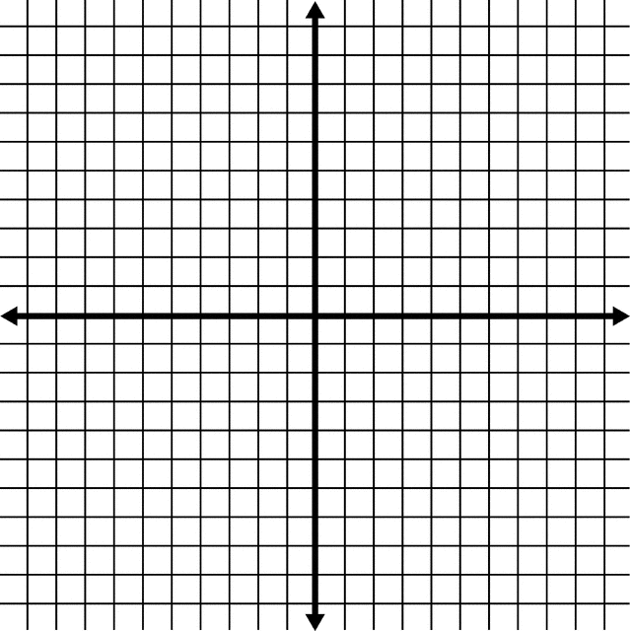
c) Write the data as a set of ordered pairs. c) Graph

d) State whether the function is discrete or continuous. Explain.

Ex3: Determine whether $-3x+y=8$ represents a function.
X
Y

Function Notation –
*
Ex4: For $f\left(x\right)=-4x+7$, find each value.
a) $f(2)$ b) $f\left(-3\right)+1$

Ex4b: Find $6-f(5)$ if $f\left(x\right)=2x-3$

Nonlinear function –

Ex5: If $h\left(t\right)=-16t^{2}+68t+2$, find each value.
a) $h(4)$ b) $2[h\left(g\right)]$

