*Learning Target:
*Critical Content:
Coordinate System –
Label the following diagram:
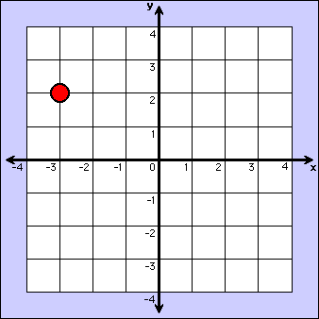

Ordered Pair –
x-coordinate –
y-coordinate –
Relation –
*
Mapping –
Domain –
Range –

Ex1: a) Express $\{\left(2, 5\right),\left(-2, 3\right),\left(5,-2\right),\left(-1,-2\right)\}$ as a table, a graph, and a mapping.
x | y
b) Determine the domain and the range of the relation.

Ex1: a) Express $\{\left(4,-3\right),\left(3,2\right),(-4,1),\left(0,-3\right)\}$ as a table, a graph, and a mapping.
x | y
b) Determine the domain and the range of the relation.

Independent Variable –
*
Dependent Variable –
*
Ex2: Identify the independent and dependent variables for each relation.
a) The dance committee is selling tickets to the Fall Ball. The more tickets that they sell increases the amount of money they can spend for decorations

b) Generally, the average price of going to the movies has steadily increased over time.

2a) The air pressure inside a tire increases with the temperature.

Ex3: The graph represents the distance Francesca has ridden on her bike. Describe what happens in the graph.
(Tell me a story!)

Ex3a: Describe what is happening in the graph. Come up with a story!

